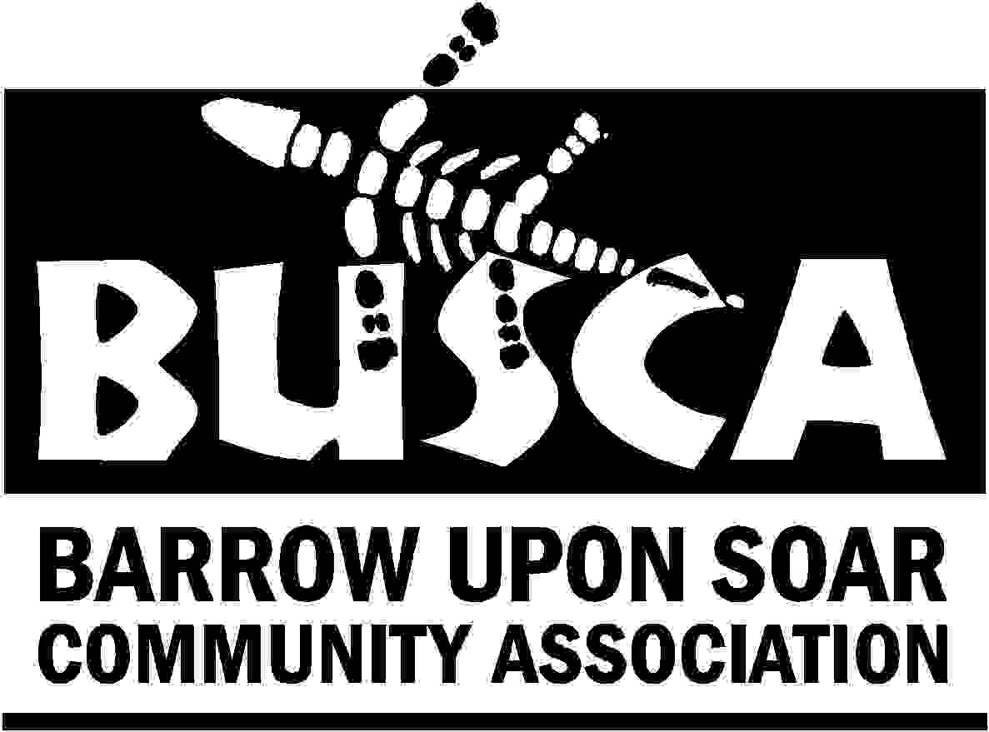
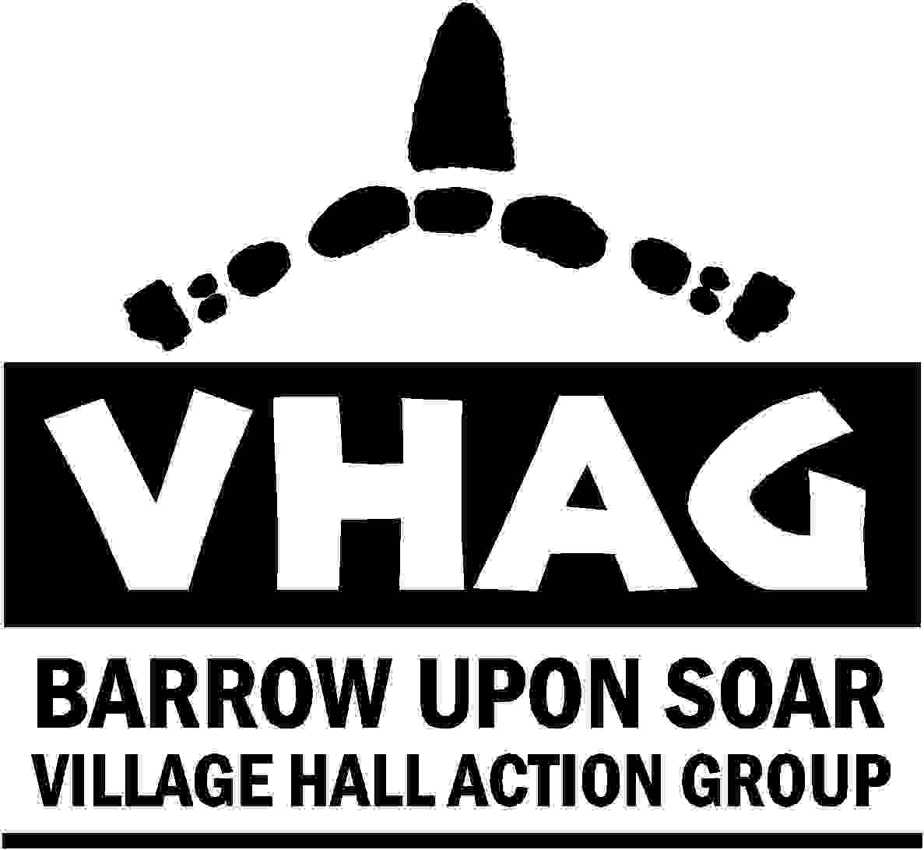
AUCTION
OF PROMISES

LOTS (In no particular order)

- Pillion ride on a custom Harley Davidson with a Photoshoot and CD of Pictures.
Donor: Ian Shonk
- Tickets to see Swan Lake, The Snow Queen, or The Nutcracker at the London Coliseum.
Donor: English National Ballet
- Belvior Castle Family ticket (2 Adults and 3 Children)
Donor : His Grace the Duke of Rutland
- Belvior Castle Family ticket (2 Adults and 3 Children)
Donor : His Grace the Duke of Rutland
- Two tickets to see Disney On Ice
Donor: Nottingham Arena
- A Knitted item
Donor: Carol Westbury
- A week in a house in France
Donor: Kathryn Timmons
- Set of Katate lessons
Donor: Pete Statham (Barrow Karate Club)
- Hair and beauty makeover
Donor: Bliss hairdressing
- Cheese and Pickle Sandwich
Donor: ?
- A day with a Stained/fused glass artworker
Donor: Claire Williamson Glassworks
- Tour of the Leicester City football (Walkers) Stadium for four
Donor: Leicester City Football Club
- Switching on of the Christmas Lights
Donor: ?
- To be the Auctioneer for the next lot
Donor: ?
- Cheuffeur driven in a Baby Bentley
Donor: Mick Goodwill
- Sunday Lunch for two at the Quorn Grange Hotel
Donor: Quorn Grange Hotel
- Family portrait
Donor: Dennis Doyle
- Boat Trip and Tea on the River Soar
Donor: Barry and Joy Atkinson
- Therapy Session
Donor: Anne Gregory Clinic
- Rock/Punk Band Gig
Donor: TRASH
- Hypnotherapy stop smoking sessions
Donor: Ann Mooney
- Be the first to book the new Village Hall
Donor?

